

TOPIC: Ethical hacking and counter mesaures
NAME:Abdimajid ismail
ADM NO:Bsccs/2024/32288
COURSE: BACHELOR OF SCIENCE IN COMPUTER SCIENCE
DEPARTMENT: COMPUTING AND INFORMATICS
CREATIVE TASK DONE : 1.

LECTURER : MICHAEL NYORO
SUBMISSION DATE: 4th June 2026

DECLARATION
I, Abdimajid Abdinasir Ismail, hereby declare that all information in this document has been obtained and presented in accordance with academic rules and ethical conduct. Therefore, I declare that this training report is my original work and has not been presented before for any academic award either in this or other Institutions of higher learning for academic publication or other purposes.
STUDENT NAME:Abdimajid Abdinasir Ismail
ADM NO: BSCCS/2024/32288
Signature:Abdimajid Abdinasir Ismail
Date: 4th june 2026

Table of Contents
1. Preliminaries
- Title Page ............................................................................................................................ i
- Student Declaration ............................................................................................... ii
2. Lab Environment & Initial Reconnaissance
- 1. Environment Initialization ..................................................... 1
  - 1.1 Launching Metasploit Framework (msfconsole)
- 2. Local Network Interface & Routing Discovery ........................................................... 1
  - 2.1 Subnet and Gateway Identification (ip a / ip route)
- 3. Fast Network Subnet Reconnaissance .......................................................................... 2
  - 3.1 Active Host Discovery Sweep via Nmap
3. Target Profiling & Vulnerability Assessment
- 4. Deep Service Fingerprinting & Aggressive OS Detection ......................... 2
  - 4.1 Banner Grabbing and Software Stack Identification
  - 4.2 Target Operating System Profiling
- 5. Vulnerability Search & Module Selection ......................................... 3
  - 5.1 Identifying MS14-017 RTF Memory Corruption Vulnerability
4. Exploit Weaponization & Execution
- 6. Exploit Module Context Mounting ..................................................... 3
  - 6.1 Staging the File-Format Exploit and Meterpreter Payload
- 7. Payload Configuration Options Inspection ............................................. 4
  - 7.1 Reviewing Module Variables and Handler Settings
- 8. Exploit Execution & Artifact Generation .................................................................... 4
  - 8.1 Malicious RTF File Compilation
  - 8.2 Setting Up the Reverse TCP Handler Listener
GITHUB LINK: https://github.com/abdimajid637

1. Environment Initialization
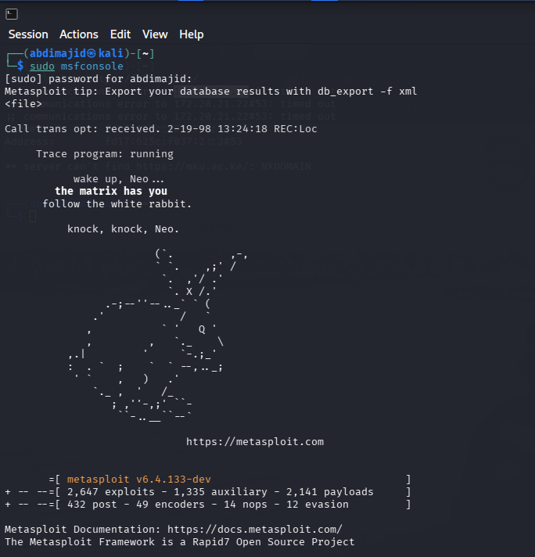

2. Local Network Interface & Routing Discovery
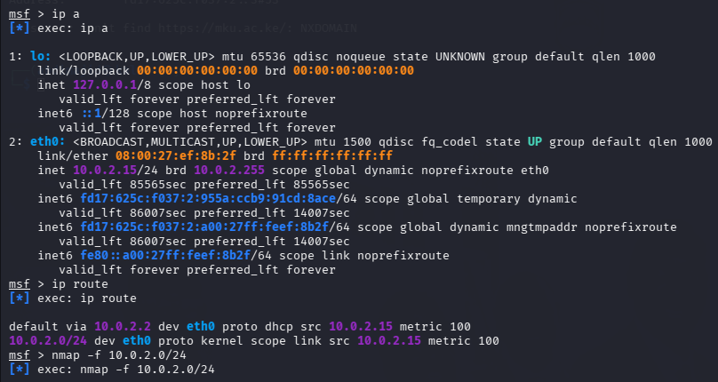

3. Fast Network Subnet Reconnaissa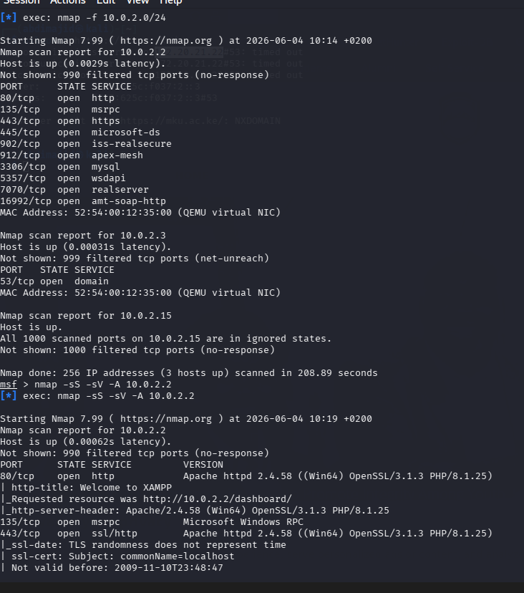nce

4. Deep Service Fingerprinting & Aggressive OS Detection
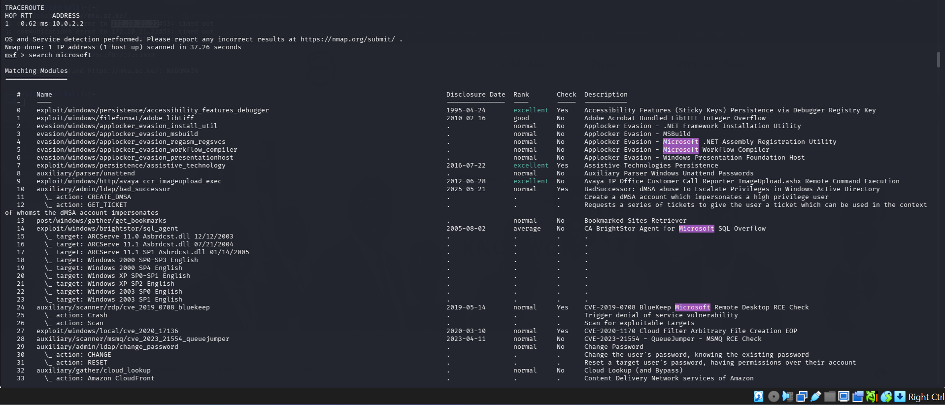

. 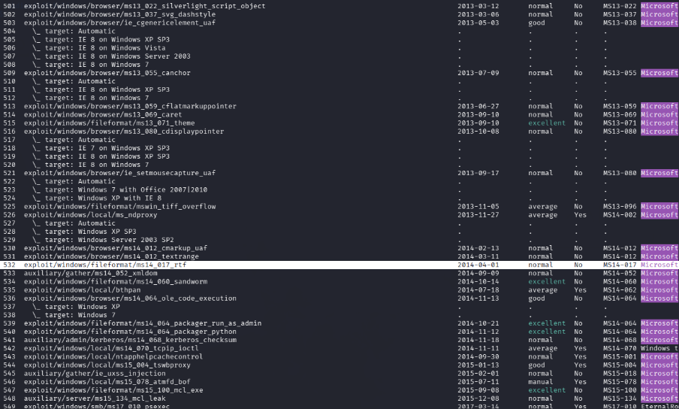
6. Exploit Module Context Mounting
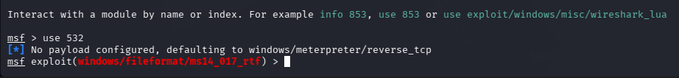

7. Payload Configuration Options Inspection
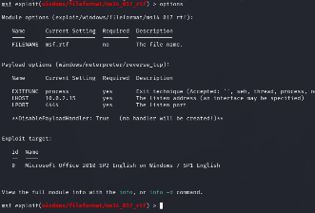
8. Exploit Execution & Artifact Generation
[